ART 361Saints and She-Devils:

Images of Women inWestern Europe

222 McWethy Christina Penn-Goetsch
M-F: 10 a.m.; 1 p.m. Office 214 McWethy
Office Hours: M and Th, 3-5 pm Office: 895-4137
Home: 319 338-7438
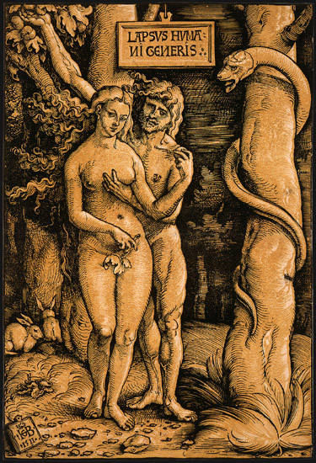

…nothing so casts down the manly mind from its heights as the fondling of women, and those bodily contacts which belong to the married state. – Thomas Aquinas

Even within the context of marriage, a woman was seen as a threat; Aquinas’s views were characteristic of the late medieval ages. Saints and She-devils will explore the most common depictions of women during these periods and will begin with the subjects of Eve and the Virgin Mary. Although the Blessed Mother was held high on a pedestal, women in the Christian West were often described as having overwhelming sexual appetites that determined their place and role in late Medieval and Early Modern society (1300-1650). Those few who escaped such a stereotype ultimately demonstrated absolute control over their female bodies. Such saints include Mary Magdalen, Thecla, Catherine of Alexandria, and Susanna. Their lives inevitably became models for nuns and queens.
Figure 1. Hans Baldung Grien, Fall of Man, 1511.

Art conveys a great deal of information about what people believed, even if the scriptures provided very different information. We will discover that the presumed behavior of one woman not only led to the Fall in the Garden of Eden, but the behavior of almost all of them seemed to continue this tradition and contribute to the downfall of mankind. Some of the most popular Flemish and German prints show how man is led astray by feminine wiles, as is the case with Phyllis, Delilah, and (curiously) Judith. Ultimately, we will see how these models are related to those of witches and peasants.

There are a number of different assignments to be addressed in class, and a large portion of your grade will involve participation. Class discussion will involve the close examination of images within their historical contexts; however, there will be no single textbook and rarely a set reading for all the material covered on a given day. Rather you must make use of the bibliography to supplement listed assignments. Regular readings include Margaret Miles’ Carnal Knowing, Marina Warner’s Alone of All Her Sex: The Myth and the Cult of the Virgin Mary and Christa Grössinger’s Picturing Women in Late Medieval and Renaissance Art. There is one short directed essay and a research paper that considers a single theme of your choice along with two exams.

Class Participation 15% (regular class attendance alone is a “C”*)
Directed Essay 15%
Midterm 25%
Research Paper 20%
Final 25%

*If you miss more than two class sessions, morning or afternoon, your participation grade is lowered unless excused. Nevertheless, you should always tell me if you missed or will miss a class.

Learning Objectives

This course addresses the Education Priorities of Cornell College with a particular focus on the following outcomes:

- Students will gain proficiency in analyzing or “reading” visual imagery in early modern Europe and how this imagery informs our understanding of gender and race in the past and the present. This proficiency will be developed through the close examination of images in group discussions and written assignments according to the professional standards and style of the discipline of art history. (Communication, Citizenship, Ethical Behavior, and Intercultural Literacy)
- Art history courses integrate the recognition of particular objects as a reflection of individual cultures and time periods. This course will therefore expect that students will be able to recognize how such images have been discussed by art historians as well as their methodologies and be able to employ information literacy tools in order to assist in this process. (Knowledge, Inquiry, and Reasoning)

Additional Accommodations

Students who need accommodations for learning disabilities must provide documentation from a professional qualified to diagnose learning disabilities. For more information see
cornellcollege.edu/disabilities/documentation/index.shtml

Students requesting services may schedule a meeting with the disabilities services coordinator as early as possible to discuss their needs and develop an individualized accommodation plan. Ideally, this meeting would take place well before the start of classes.

At the beginning of each course, the student must notify the instructor within the first three days of the term of any accommodations needed for the duration of the course.

Required Books

Grössinger, Christa. Picturing Women in Late Medieval and Renaissance Art. Manchester, 1997. (704.9424 G914p)
Miles, Margaret. Carnal Knowing: Female Nakedness and Religious Meaning in the Christian West. New York, 1991. (246 M595c 1991)
Warner, Marina. Alone of All her Sex: The Myth and the Cult of the Virgin Mary. New York, 1983. (232.91 w246A 1983)

The above books are available in the bookstore. Other Readings will be provided in class and/or Moodle. A few are articles listed on the syllabus and available from Electronic journal databases.
Directed Essay

Essay One: Read the following articles and books that discuss Marian iconography and symbolism of Robert Campin’s Mérode Triptych from the Cloisters at the Metropolitan Museum of Art. The articles date from 1945 to 1992. The paper should be between four and five pages in length and include references or citations to at least seven of the sources listed below as well as include Marina Warner’s Alone of All Her Sex: The Myth and Cult of the Virgin as one of the seven sources from which you choose to cite. Make sure to begin your essay with a thesis that you can defend with specific examples from the readings. All paragraphs should have a topic sentence that match the order of topics outlined in your introduction. As always, you must employ internal citations when you refer to an author’s ideas or observations. This is true whether or not you use a direct quote. Use a citation whenever you make reference to any information that is not common knowledge. If you do not use this form of identifying your source or sources, it is considered plagiarism. Plagiarism will result in a failing grade for the paper or the course.

Cornell College expects all members of the Cornell community to act with academic integrity. An important aspect of academic integrity is respecting the work of others. A student is expected to explicitly acknowledge ideas, claims, observations, or data of others, unless generally known. When a piece of work is submitted for credit, a student is asserting that the submission is her or his work unless there is a citation of a specific source. If there is no appropriate acknowledgement of sources, whether intended or not, this may constitute a violation of the College’s requirement for honesty in academic work and may be treated as a case of academic dishonesty. The procedures regarding how the College deals with cases of academic dishonesty appear in The Compass, our student handbook, under the heading “Academic Policies – Honesty in Academic Work.”

I would prefer that you follow The Chicago Manual of Style when citing sources. You can find this sort of information in a writing style guide or handbook such as Diana Hacker, A Pocket Style Manual, and a section of the manual is on the Moodle site. Information also may be found at the Writing Studio Website at Cole Library or (http://www.wisc.edu/writing/Handbook/DocChicago.html#electronic).

This particular assignment requires you to incorporate one of the textbooks for this course, Alone of All Her Sex along with at least six other sources listed in the syllabus. Warner comes from a strong Roman Catholic background, but she is not writing a devotional text. Instead, she approaches the material like an anthropologist. As you write your essay, you should keep the author’s thesis and methodology in mind. You will not be able to address all of the points addressed in the book for this particular assignment; however, you can develop a nice essay with examples taken from the text. Try to examine the material according to the specific historical context. This task can be challenging, as we all come from specific religious traditions that may have theological views that do not match with those of the Early Modern Era and the tradition that we are studying in this class. Due Thurs., March 28.

Sources
(Entries are written in the order of a citation or footnote according to the Art Bulletin Style. You should use the Chicago Style format. Articles are largely available on JSTOR or EBSCO Art Source.)

M. Botvinick, “The Painting as Pilgrimage: Traces of a Subtext in the Work of Campin and His Contemporaries,” Art History, XV (1992): 1-18.

E. Callmann, “Campin’s Maiolica Pitcher,” Art Bulletin, LXIV (1982): 629-31.

Jozef de Coo, “A Medieval Look at the Mérode Annunciation,” Zeitschrift für Kunstgeschichte, XLIV (1981): 114-32.

J. Duschesne-Guillemin, “On the Cityscape of the Mérode Altarpiece,” Metropolitan Museum Journal, XI (1976): 129-31.

M. Freeman, “The Iconography of the Mérode Altarpiece,” Metropolitan Museum of Art Bulletin, XVI (1957): 130-39.

C. Gottlieb, “Respiciens per Fenestra: The Symbolism of the Mérode Altarpiece,” Oud Holland, LXXXV (1970): 65-84 (Moodle).

C. Hahn, “Joseph Will Perfect, Mary Enlighten and Jesus Save Thee: The Holy Family as Marriage Model in the Mérode Triptych,” Art Bulletin, LXVIII (1986): 54-66.
T. à Kempis, Imitation of Christ, New York, 1880. ebook (242.1 Im4o)

M.A. Lavin, “The Mystic Winepress in the Mérode Altarpiece,” Studies in Late Medieval and Early Renaissance Painting in Honor of Millard Meiss, I, New York, 1978, 297-301. (Moodle)

C.I. Minott, “The Theme of the Mérode Altarpiece,” Art Bulletin, LI (1969): 267-71.

H. Nickel, “The Man Beside the Gate,” Metropolitan Museum of Art Bulletin, XXIV (1966): 237-44.

M. Schapiro, “Muscipula Diaboli, The Symbolism of the Mérode Altarpiece,” Art Bulletin, XXVII (1945): 182-87.

_________, “A Note on the Mérode Altarpiece,” Art Bulletin, XLI (1959): 327-28.

F. Thurlemann, Robert Campin: A Monographic Study with Critical Catalogue, Munich: Prestel, 2002, 58-76. (Moodle)

J. de Voragine, The Golden Legend, 2 Vols, Princeton: Princeton, 1993. ebook (282.0922 J159g)

I. Zupnick, “The Mystery of the Mérode Mousetrap,” Burlington Magazine, CVIII (1966): 126-133 (and letters in response, J. Jacob, 373-74; 430; H. Nickel, 577).

Research Paper or Project

A large portion of your grade depends on your submission of a paper between 5 and 8 pages in length. The paper should be a critical analysis of a specific question or problem (a particular image or story depicted in art), and should explore the thesis in a logical well-ordered manner. I am open to the possibility of a topic that has a primary literary focus, as long as you can connect it to artwork and the themes examined in class. We must work together to help form the topic during my office hours, after class, or by special arrangement. Everyone must discuss their projects with me in advance. (If you are an advanced art major, I will consider an art project accompanied by a 3 to 4 page paper) Papers must be double-spaced with reasonable margins, accompanied by footnotes, bibliography and photocopied or scanned illustrations with captions. Employ the Chicago Manual of Style. Make sure to use footnotes, when you refer to information or observations from another source. Plagiarism is unacceptable and will result in a failing grade. Ask, if you have questions.

When to Use a Footnote
There are three primary areas that should include footnotes or parenthetical notations:

- If you use the exact words of an author, use a citation. Place the words within quotation marks.
- If you draw upon the ideas, arguments, or observations of others, use citations.
- If you include facts not widely available or known, use citations.

Some scholars also use a footnote, when they want to direct the reader toward useful information on a given subject or to explain an argument further. As you cite sources, make sure to go to the original source for an idea whenever possible.

Deciding on a Topic

You may want to begin by looking at the attached bibliography or those included with the readings assigned for class. The sources are good and will provide direction toward areas and controversies that may be of interest. Almost all situations will require you to search for periodical literature. EBSCO –Art Source is often the most useful research engine for Art History in the Cole library, but it is by no means exhaustive. JSTOR also is useful as is EBSCO—Academic Search Premier. This is an advanced art history class. If you are new to researching papers in the discipline, you should set up an appointment with me or Gregory Cotton in the Cole Library. Any strong research paper should aim to have about eight to ten sources and always should demonstrate that you consulted the appropriate material listed in the syllabus, as they represent respected research. In most cases, interlibrary loan will be necessary; therefore, you must start the research process early. You will be meeting with me to show me your bibliography on Tuesday, April 2. Beware of websites. They may be useful when looking for basic information; however, most material is not scholarly in nature and rarely gives appropriate credit to another author. This problem is quite pronounced in this particular area of study. There are a few exceptions. Check with me, if you have questions about any source. Final research papers are due Monday, April 8. Pace yourself. I have given you ample time to work on your papers, but you must allow yourself time to complete the necessary readings and the research paper.

Although the course focused on the image of woman, you may choose a topic that considers a male figure or even a non-human image. Possible topics can also address art from the Modern or Post-modern periods. Each paper topic can be carefully adjusted to the interests and needs of the class participant. However, the point of the course requires that you consider the image in light of the social construction of gender roles. Try to avoid using general survey texts as a source. However, consulting J. Synder’s Northern Renaissance Art or F. Hartt’s Italian Renaissance Art may be useful at the beginning of the process. Encyclopedias and dictionaries are also tertiary sources that should not be cited in any research paper. Feel free to ask me why this is the case for art history. Primary and secondary sources vary from one discipline to another. Many appropriate materials are on reserve in the library and you may employ the bibliography in the back of the Grössinger text. All topics must be approved by the professor at least one week in advance, or the paper may not be accepted. Here are some suggestions:

Danaë Queen of Sheba
Diana Bathsheba
Michelangelo’s Sibyls Salome
Delilah Venus
Catherine of Alexandria Ursula
Barbara Thisbe
Veronica Pope Joan
Judith Mary Magdalene
Cleopatra Sin or Dragon Error (Paradise Lost)
Dido Joan of Arc
Lucretia Lady Macbeth (Shakespeare)
Susanna Cleopatra
Potiphar’s Wife Esther
Lucy Virginia
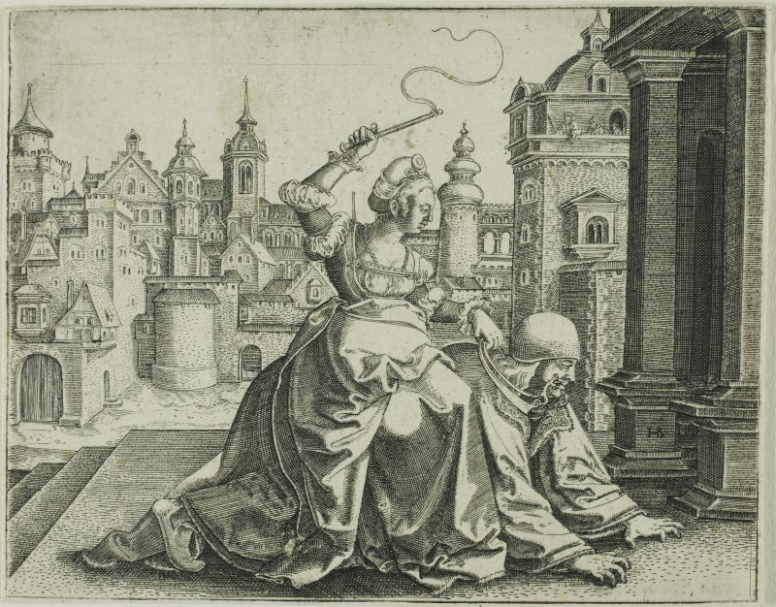
Figure 2. Hans Brosamer, Phyllis and Aristotle, 1520-51.

Rubric for Saints and She-Devils Research Papers/Projects
(300-level Course Requirements—Penn-Goetsch)

A = Superior Work that Exceeds Expectations
A-/B+ Excellent Work

- Paper has a clear thesis and develops a specific argument.
- Paper addresses the approved topic and incorporates primary source material.
- Paper acknowledges sources and employs citations correctly in the Chicago Style.
- Paper includes the most respected secondary source material on the topic within the context of a thorough bibliography with ten or more sources.
- Paper demonstrates a keen awareness of the material read
- Paper relates the argument back to discussions and readings offered in class.
- Paper develops an innovative or particularly creative approach to the assignment

B = Good Work that Characterizes Strong Upper-level Engagement with Material

1. Paper has a clear thesis and develops a specific argument.
- Paper addresses the approved topic and incorporates primary source material.
- Paper acknowledges sources and employs citations correctly
- Paper includes a solid bibliography of useful secondary sources (10 total of combined primary and secondary sources).
- Paper demonstrates a keen awareness of the material read.

C=Adequate Work that Meets Basic Requirements for the Assignment

1. Paper has a clear thesis and develops a reasonably clear argument.
- Paper addresses the approved topic.
- Paper acknowledges sources and employs citations reasonably well.
- Paper includes a bibliography of at least six sources.

D=Does not Meet One of the Basic Requirements for the Assignment

- Paper has a clear thesis and sustains an argument.
- Paper addresses an approved topic.
- Paper employs citations reasonably well.

If you do not acknowledge your sources, your assignment enters the realm of plagiarism. Plagiarism results in an F for the paper grade.

Tentative Syllabus
(Class usually meets at 10 am and 1 pm unless noted below.)

Eve

Mon., March 18 Introduction—Dangerous Women
Ideology and Gender in the Early Modern Era
(Class meets 10-11 am and 1:00-3:00 pm today)
Read: Read Mary Garrard “Why Are These Women Dangerous? In Dangerous Women, New York, 2018, 15-21; Kimberly Dennis, “The Danger of Biblical Women,” In Dangerous Women, New York, 2018, 23-29; and Grössinger, 1-19
Suggested: Genevieve Lloyd, The Man of Reason: “Male” and “Female” in Western Philosophy, Minneapolis: University of Minnesota Press, 1984, Chaps. 1-3 (Moodle)

Tues., March 19 Augustine’s Penis and Original Sin
Read: Miles, Preface and Introduction, Chap 3 (Part II)
Suggested: Augustine, The City of God, Trans. by Marcus Dods, New York: Barnes and Noble, 2006, Books XII – XIV (Moodle)

Wed., March 20 Eve and the Temptation
Read: Miles, Chap. 4 (Part II)
Suggested: H. D. Russell, Eva/Ave: Women in Renaissance and Baroque Prints, Washington, DC: National Gallery, 1990, 113-29. (Moodle and On Reserve Oversize 769 R913e 1990)

Thurs., March 21 Sexuality and the Flesh
Read: Witcombe (Handouts) and
James Clifton, “Gender and Shame in Masaccio’s Expulsion from the Garden of Eden,” Art History, 22 (1999): 637-55. (JSTOR or Link from Moodle)

Fri., March 22 The Female Body as Text
Read: Miles, Chap. 5 (Part II)
Jane Schuyler, "Michelangelo's Serpent with the Two Tails," Source, 1990, 23-29 (Moodle)
Suggested: Maria Rzepinska, "The Divine Wisdom of Michelangelo in The Creation of Adam," Artibus et Historiae, Vol. 15, 1994, 181-187. (JSTOR or Link from Moodle); Barbara Wisch, "Vested Interest: Redressing Jews in Michelangelo's Sistine Ceiling," Artibus et Historiae, Vol. 24, 2003, 143-172. (JSTOR or Link from Moodle)

Mary

Mon., March 25 The New Eve
Peruse: L. Steinberg, The Sexuality of Christ in Renaissance Art and Modern Oblivion, Chicago, 1983, 1-108. (On Reserve 704.948 St34s 1996)
Read: C. Bynum, The Body of Christ in the Later Middle Ages: A Reply to Leo Steinberg,” Renaissance Quarterly 39 (1986) 399-439 (JSTOR or Link from Moodle)

Tues., March 26 The Virgin’s Milk and the Cup of Salvation
Read: Grössinger, 20-43
Suggested: Lane, 13-77 (Moodle and On Reserve 755.2 L24aL 1984)

Wed., March 27 Family Values: Saint Anne’s Three Husbands
Read: C. Hahn, “Joseph will Perfect, Mary Enlighten and Jesus Save Thee: The Holy Family as Marriage Model in the Merode Triptych,” Art Bulletin, 67 (1986): 54-66. (EBSCO/Art Source, JSTOR, or Link from Moodle);

Saints

Thurs. March 28 Becoming Male: Female Saints
Read: Miles, Chap. 2 (Part I).
Kim E. Butler, "The Immaculate Body in the Sistine Ceiling," Art History, Vol. 32, 2009, 250-289. (EBSCO/Art Source and Link from Moodle); Suggested: Acts of Paul and Thecla (Moodle)
Directed Research Paper Due

Fri., March 29 Midterm 9:00—11:00 am
Film: The Da Vinci Code
Afternoon Class runs from 12:45 to 3 p.m.

Mon., April 1 Becoming Male, continued
Film: Pope Joan Afternoon Class starts at
12:30 pm and lasts until 3 pm

Tues. April 2 Leonardo and Mary Magdalene
Read: M. Och, “Vittoria Colonna and the Commission for Mary Magdalen by Titian,” In Beyond Isabella: Secular Women Patrons of Art in Renaissance Italy, S.E. Reiss and D.G. Wilkins, eds., Kirksville, MO: Truman State, 2001, 193-223. (On Reserve 707.9 B460r 2001 and Moodle)
Suggested: S. Haskins, “Beata Peccatrix,” “The Weeper,”and “Dulcis Amica Dei” from Mary Magdalen: Myth and Metaphor, New York: Harcourt, Brace & Co.,

Wed., April 3 The Heroine: Judith and Lucretia Among Others
Read: Y. Even, “The Heroine as Hero in Michelangelo’s Art,” Woman’s Art Journal, 11, 1990, 29-33. (JSTOR and Link from Moodle) and Linda C. Hults, “Dürer’s Lucretia: Speaking the Silence of Women,” Signs, 16, 1991, 205-237. (JSTOR and Link from Moodle)
Suggested: H. D. Russell, Eva/Ave: Women in Renaissance and Baroque Prints, Washington, DC: National Gallery, 1990, 29-73. (On Reserve Oversize 769 R913e 1990)

Thurs., April 4 The Blessed Virgin as Role Model: Queens
Read: D. Fischlin, “Political Allegory, Absolutist Ideology, and the Rainbow Portrait of Queen Elizabeth I,” Renaissance Quarterly, 50 1997, 175-206 (JSTOR and Link from Moodle)
Suggested: Natalie Zemon Davis, “Women on Top,” In Society and Culture in Early Modern France, Stanford, 1975, 124-51 (Moodle)

She-Devils

Fri., April 5 Women On the Margins:Witches
Read: D. Neave The Witch in Early 16th-century German Art,” Women’s Art Journal, 9, 1988, 3-9. (JSTOR and Link from Moodle) and Kramer and Sprenger, Part I, Questions 5-10, pp. 31-65. (On Reserve and Moodle)
Suggested: L. C. Hults, “Baldung and the Witches of Freiberg: The Evidence of Images,” Journal of Interdisciplinary History, 18, 1987, 249-76. (JSTOR and Link from Moodle)

Mon., April 8 Carnal Seduction: The Power of Women Series
Read: Grössinger, 94-138
Suggested: H. D. Russell, Eva/Ave: Women in Renaissance and Baroque Prints, Washington, DC: National Gallery, 1990, 147-75. (On Reserve Oversize 769 R913e 1990 and Moodle)
Research Papers Due by 5:00 p.m.

Tues., April 9 Good Wife/Bad Wife
Read: Grössinger, 43-93
Guido Ruggiero, “Hunting for Birds in the Italian Renaissance,” In Erotic Cultures of Renaissance Italy, S.F. Matthews-Grieco, ed., New York: Routledge, 2010, 1-18. (Moodle)
Suggested: A. Steward, “Distaffs and Spindles: Sexual Misbehavior in Sebald Beham’s Spinning Bee,” In Saints, Sinners, and Sisters, J.L. Carroll and A.G. Stewart, eds., Aldershot: England, 2003, 127-154. (On Reserve 704.9424 Sa281 2003)

Wed., April 10 Final Exam (9 am-12 noon)

Bibliography

(For the most part, these are Secondary Sources On Reserve or Available on JSTOR or EBSCO Art Source)

P. Almond, Adam and Eve in Seventeenth Century Art, Cambridge, 1999. (222.1106 .AL68ad)

K. Ashley and P. Scheingorn, eds., Interpreting Cultural Symbols: Saint Anne in Late Medieval Society, Athens, GA, 1990.

R.H. Bloch, Medieval Misogyny and the Invention of Western Romantic Love, Chicago, 1991. ebook

Boccaccio, Concerning Famous Women, trans. by V. Brown, London, 2001. (920.72 B63c)

D. Brown, et. al., Virtue and Beauty: Leonardo, Ginerva de’Benci, and Renaissance Portraits of Women, Princeton, 2001. (Over 257.4 V819 2001)

C.W. Bynum, Fragmentation and Redemption: Essays on Gender and the Human Body, New York, 1992. Ebook (233.5 B995F 1991)

__________, Jesus as Mother: Studies in the Spirituality of the High Middle Ages, Berkeley, 1982. ebook

__________, Holy Feast and Holy Fast, Berkeley, 1987. Ebook (248.46 B995h)

J.L. Carroll and A.G. Stewart, eds., Saints, Sinners and Sisters: Gender and Northern Art in Medieval and Early Modern Europe, Aldershot, England, 2003. (704.9424 Sa281 2003)

M. Carroll, “The Erotics of Absolutism: Rubens and the Mystification of Sexual Violence,” in The Expanding Discourse: Feminism and Art History, N. Broude and M. Garrard, eds., New York, 1992. (704.042 Ex71) New Copy Order for Cole Library

E. Cropper, “The Beauty of Women: Problems in the Rhetoric of Renaissance Portraiture,” in Rewriting the Renaissance: The Discourse of Sexual Difference in Early Modern Europe, edited by M. Ferguson, M. Quilligan, and N. Vickers, Chicago, 1986, 175-90. (305.3 R328 1987)

J. Delumeau, History of Paradise: The Garden of Eden in Myth and Tradition, trans. by M. O’Connell, New York, 1995.

Annette Dixon, Women Who Ruled: Queens, Goddesses, and Amazons in Renaissance and Baroque Art, London, 2002. (704. 9424 W842 2002) New Copy Ordered for Cole

L. Dresen-Coenders, et. al., eds., Saints and She-Devils, London, 1987. (704.9424 Sa28 1987)

A. Dunlop, “Flesh and the Feminine: Early-Renaissance Images of the Madonna with Eve at Her Feet,” Oxford Art Journal, 25, 2002, 127-48.

Y. Even, “The Heroine as Hero in Michelangelo’s Art,” Woman’s Art Journal, 11, 1990, 29-33.

D.N. Fewell, “Reading the Bible Ideologically: Feminist Criticism,” in S. McKenzie and S. Haynes, eds., To Each Its Own Meaning: An Introduction to Biblical Criticism and Their Application, Louisville, 1993.

R. Goffen, “Titian’s Sacred and Profane Love and Marriage,” in The Expanding Discourse: Feminism and Art History, N. Broude and M. Garrard, eds., New York, 1992, 111-26. (704.042 Ex71) New Copy Ordered for Cole Library

J. Goldberg, “Fatherly Authority: The Politics of Stuart Family Images,” in Rewriting the Renaissance: The Discourse of Sexual Difference in Early Modern Europe, edited by M. Ferguson, M. Quilligan, and N. Vickers, Chicago, 1986, 3-32. (305.3 R328 1987)

Grössinger, Christa, Picturing Women in Late Medieval and Renaissance Art, Manchester, 1997. (704.9424 G914p)

C. Hahn, “Joseph will Perfect, Mary Enlighten and Jesus Save Thee: The Holy Family as Marriage Model in the Merode Triptych,” Art Bulletin, 67 (1986): 54-66.

S. Haskins, Mary Magdalen: Myth and Metaphor, New York, 1994. (226.0924 m369h)

S. Harding and M. Hintikka, eds., Discovering Reality: Feminist Perspectives on Epistemology, Metaphysics, Methodology, and Philosophy of Science, Dordrecht, 1983.

A.K. Hieatt, “Hans Baldung Grien’s Ottawa Eve and Its Context,” Art Bulletin, 65 (1983): 298-9.

L.C. Hults, “Baldung and the Witches of Freiberg: The Evidence of Images,” Journal of Interdisciplinary History, 18, 1987, 249-76.

__________, The Witch as Muse: Art, Gender, and Power in Early Modern Europe, Philadephia, 2005. (704.949 H8979 28 2005)

G. Jones and S. Matthews Grieco, Picturing Women in Renaissance and Baroque Italy, Cambridge, 2001. (704.9424 P589 2001)

M.M. Kahr, “Delilah,” in Feminism and Art History, N. Broude and M. Garrard, eds., New York, 1982. (701.03 F349)

J. Kelly, “Did Women Have a Renaissance,” in Women, History, and Theory, Chicago, 1984. Ebook

T. à Kempis, Imitation of Christ, reprint edition, London, 1880. (242.1 Im4o) ebook

Karen King, Gospel of Mary of Magdala, Santa Rosa, California, 2003. (229.8 K583g 2003) (229.8 K583g 2003)

M. King and A. Rabil, Jr., eds., Her Immaculate Hand: Selected Works By and About the Women Humanists of Quattrocento Italy, Binghamton, New York, 1983.

C. Klapisch-Zuber, Women, Family, and Ritual in Renaissance Italy, translated by L.G. Cochrane, Chicago, 1985. (306.0945 K662wo 1985)

H. Kramer and J. Sprenger, The Malleus Maleficarum, reprint edition, trans. by M. Summers, New York, 1971. (133.4 In7m 1971)

M.W. Labarge, A Small Sound of the Trumpet, Boston, 1986. (305.4 L111s)

B G. Lane, The Altar and the Altarpiece: Sacramental Themes in Early Netherlandish Painting, New York, 1984. (755.2 L24aL 1984)

L. Lange, “Women Is Not a Rational Animal: On Aristotle’s Biology of Reproduction,” in Discovering Reality: Feminist Perspectives on Epistomology, Metaphysics, Methodology, and Philosophy of Science, edited by S. Harding and M. Hintikka, London, 1983. ebook

G. Lerner, The Creation of a Feminist Consciousness: From the Middle Ages to Eighteen-seventy, New York, 1993. (305.42 L562c)

G. Lloyd, The Man of Reason: “Male” and “Female” in Western Philosophy, Minneapolis, 1984. (128.3 L776m)

Ian Maclean, The Renaissance Notion of Woman, Cambridge, 1980. (305.4 M223r)

S.F. Matthews-Grieco, ed., Erotic Cultures of Renaissance Italy, New York, 2010. (700.4538095 Er69 2010)

Miles, Margaret. Carnal Knowing: Female Nakedness and Religious Meaning in the Christian West. New York, 1991. (246 M595c 1991)

__________, Image as Insight, Boston, 1985. (246 M595i)

__________, ed., Maiden and Mother: Prayers, Hymns, and Songs and Devotions to Honour the Blessed Virgin Mary, San Francisco, 2001. (242.74 M36m 2001)

__________, “The Virgin’s One Bare Breast: Nudity, Gender, and Religious Meaning in Tuscan Early Renaissance Culture,” in The Expanding Discourse: Feminism and Art History, N. Broude and M. Garrard, eds., New York, 1992, 27-38. (704.042 Ex71) New Copy Ordered for Cole Library

A Molho, “Deception and Marriage Strategy in Renaissance Florence: The Case of Women’s Ages,” Renaissance Quarterly, 61 (1988), 193-217.

E. Muir and G. Ruggiero, eds., Sex and Gender in Historical Perspective, Baltimore, 1990. (305.3094 Se91)

D. Neave, “The Witch in Early 16th-century German Art,” Women’s Art Journal, 9, 1988, 3-9.

P. Norris, Eve: A Biography, reprint edition, New York, 1999. (222.110924 N796e)

S. Ozment, When Father’s Ruled: Family Life in Reformation Europe, Cambridge, 1983. (306.8 Oz6w)

J. A. Phillips, Eve: The History of an Idea, New York, 1984. (291.213 P544e)

E. Pomeroy, Reading the Portraits of Queen Elizabeth I, Hamden, Connecticut, 1989. (757 .EL48p 1989)

R. Radford Ruether, ed., Religion and Sexism: Images of Woman in the Jewish and Christian Traditions, New York, 1974. (261.834 R83r)

S. Reiss and D. Wilkins, eds., Beyond Isabella: Secular Women Patrons of Art in Renaissance Italy, Kirksville, MO, 2001. (707.9 5468r 2001)

L. Robinson, Wonder Women: Feminism and Superheroes. New York, 2004. ebook

S. Rubin, ed., The Female Body in Western Culture: Contemporary Perspectives, Cambridge, MA, 1986. (305.4 F349)

H. D. Russell, Eva/Ave: Women in Renaissance and Baroque Prints, Washington, DC, 1990. (769 R913e 1990)

S.L. Smith, The Power of Women: A Topos in Medieval Art and Literature, Philadelphia, 1995. (704.9424 SM66p 1995)

L. Steinberg, “Eve’s Idle Hand,” Art Journal, 35 (1975/76), 130-35.

__________, Sexuality of Christ in Renaissance Art and in Modern Oblivion, New York, 1983. (704.948 St34s 1996)

Margarita Stocker, Judith: Sexual Warrior, New Haven, 1998. (229.24J899s)

R. Strong, Gloriana: The Portraits of Queen Elizabeth I, London, 2003. (757.EL48st 1989) New Copy Ordered for Cole Library

P. Trible, God and the Rhetoric of Sexuality, Philadelphia, 1978.

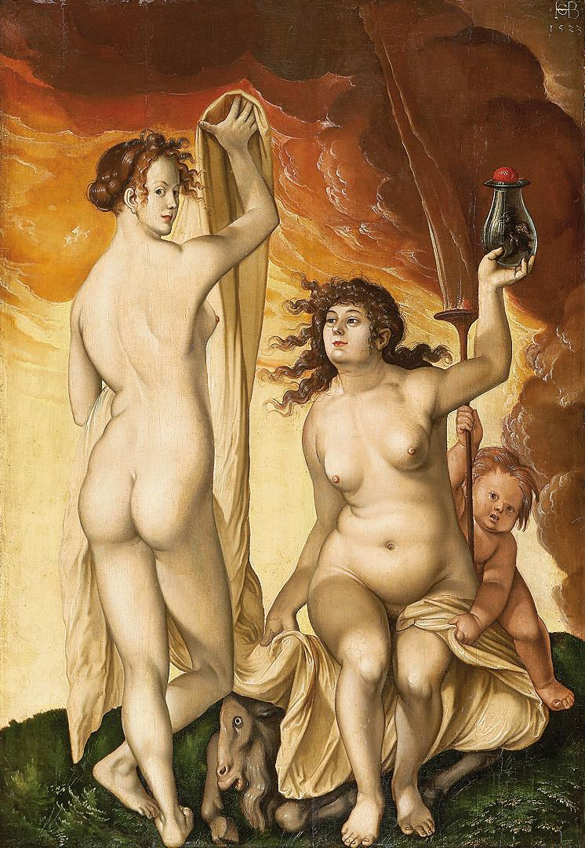
J.G. Turner, One Flesh: Paradisal Marriage and Sexual Relations in the Age of Milton, Oxford, 1987.

_________, ed., Sexuality and Gender in Early Modern Europe: Institutions, Texts, Images, Cambridge, 1993.

Jacobus de Voragine, The Golden Legend, 2 Vols, Princeton: Princeton, 1993. Ebook (282.0922 J159g)

B. Williamson, “The Virgin Lactans as Second Eve: Image of the Salvatrix,” Studies in Iconography, 19, 1998, 105-38.

D. Wolfthal, Images of Rape: The “Heroic” Tradition and its Alternatives, Cambridge, 1999. (709.949 W833i)
Hans Baldung Grien, Two Witches, 1523

